Home Page

Administrators can insert content or edit content by going to the Home Page and clicking on Actions. It’s best to create your content in a Word Document and then copy and paste the information directly into the editor. This will preserve the content and allow for simple management of the content if it ever gets over written.
Click Edit Page Content
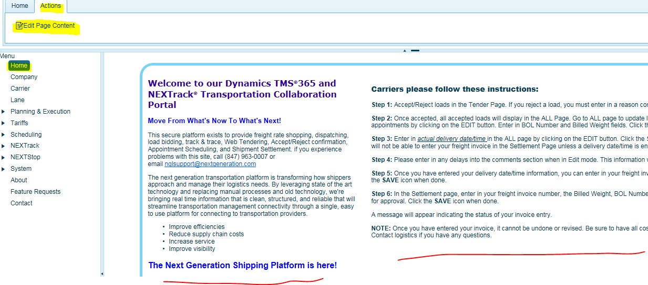

Users can update the left and right-side content with specific instructions for users, whether they’re carrier or NEXTrack users. Click Save when you’re done.
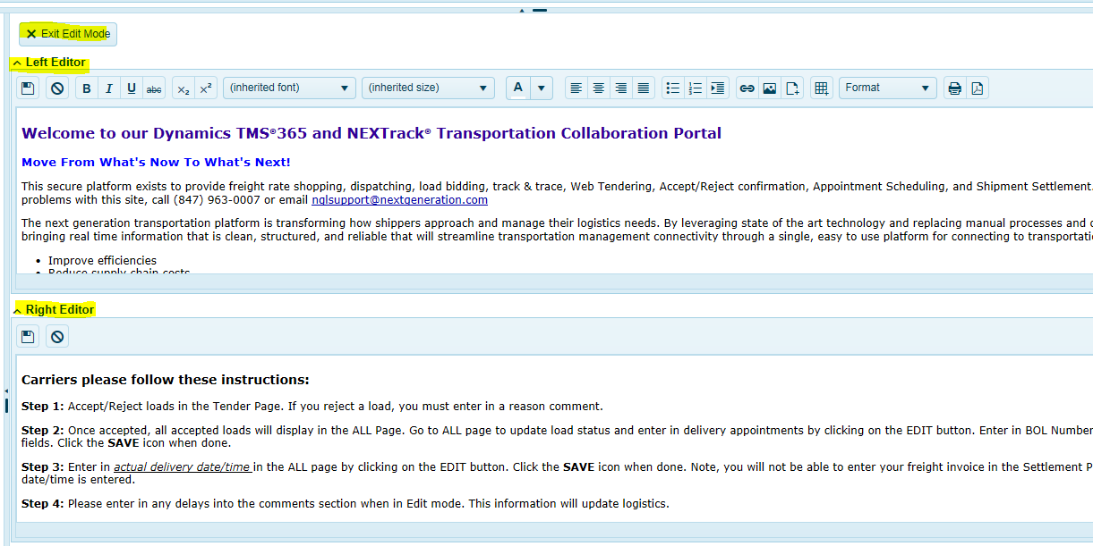

Help Page

Dynamics TMS-NEXTrack is now equipped with a content management system (screens) which allow admins or users to enter specific content related to system help or standard operating procedures.
On every page, users will see the Blue Question Mark. Click this button to reveal content notes for this page.
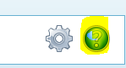

The editors will always appear in the same order top to bottom. The titles may change (based on the user and user LE) but the order of the editors in relation to each other will not.
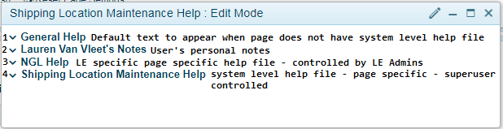

1 – Default Help file
Title will always say “General Help”
This is a single file.
It can be shown on multiple pages throughout the system. (It is not page specific)
If no System Page Level help file has been written for a given page, the Default file will be
displayed.
Only Super Users (aka NGL Staff) are allowed to edit this file

2 – User Level notes
Title will say “[UserName]’s Notes”
These are personal notes that the individual user can enter.
Only the user can see/edit their personal notes.
The notes are page specific. (aka whatever the user enters on the “Home” cannot be seen by the
user on the “All” page)
(Basically, this is a user scratch pad)

3 – Legal Entity level notes
Title will say “[Legal Entity] Help” (this is the LE of the logged in user)
These are additional help notes that only a Legal Entity Admin can enter for the Legal Entity.
Every user that belongs to this Legal Entity will see these notes
The notes are page specific
These notes obviously will be different for each customer/deployment

4 – System Page Level Help File
Title will say “[Page Name] Help”
These are the actual system level help notes for the page
Only Super Users (aka only NGL staff) are allowed to enter these notes
These files will be seen by all users on the system (if entered, otherwise they see the Default
Help File)

